NEXT Machine Management: The agricultural contractor story
As the new NEXT Machine Management module can be used irrespective of machine manufacturer, the entire pool of agricultural contractors can be monitored. With new machines (incl. supported real-time communication), documentation even takes place at the same time as the actual work – this is the biggest benefit for contractors, so that all orders can be monitored in the command centre.
The contractor Peters has invested in state-of-the-art agricultural technology and machinery, and personnel are fully deployed throughout the season. To ensure that all customer orders can be processed and all processes are optimally coordinated, the contractor uses NEXT Machine Management in his NEXT Farming software. This makes it possible to transfer the various order data to all machines. This includes, for example, field contours, steering control system lines, application maps and data on the tasks to be carried out such as drivers, machines, plant protection products, fertilisers or seeds.
Three members of staff work in the contractor's command centre during the peak season to plan the orders. One of them is Urlusa Pöttcher. Thanks to NEXT Machine Management, she always has an overview of all machines, personnel and orders.
- Simple action planning including steering control system lines, application maps and field boundaries
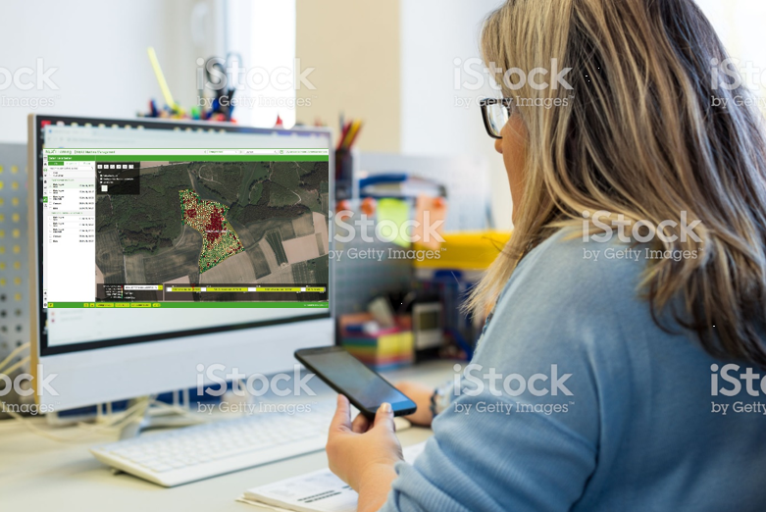
New machines transmit in real time, enabling Ursula to easily perform the following tasks:
- Route planning (support of the driver): Location and routes
- Order planning and order evaluation: Working in the field
- Time management: Customer progress
- Checking of machine data: Inspection of the quality of work
On the screen, she can monitor the various operations and check the quality using the data sent from the machines to her computer.
- Automatic documentation according to CC requirements for customers
- Fast data transfer from computer to machine and vice versa

Monitoring the procedures, Ursula realises that the work on the field for customer Heinrich Schulze Behringhoff has been successfully completed, but the employee with the machine is not yet on the way to the next customer. Although the customer's farm is just 10 km away, the team is also scheduled for another follow-up assignment and all subsequent processes are at risk of being delayed. Ursula immediately picks up the phone and calls Michael, the driver in charge, to ask whether he is encountering any serious problems.

Everything's fine. The customer Heinrich Schulze wanted a personal word with the contractor's employee to talk about the further course of action. He has leased land, for which there are no steering control system lines and field boundaries in the system yet. For another field, the city is about to expropriate the land for the construction of a road, and the data in the software must be adjusted for this area. Although time is pressing, the customer and service have top priority for Peters and his staff.
- In the NEXT Farming software, the new information (steering control system lines and field boundaries) can be quickly recorded on the basis of the order data.
After finishing the conversation with the customer, Michael gets back into the tractor and drives to the next assignment. The machine orders been processed for this customer and the data is sent back to the software. It is available to Ursula at the head office simultaneously.
Reports on each order can now be generated at the mere touch of a button, allowing the relevant order data to be viewed at a glance. Ursula can evaluate which machine did the respective work in the fields and when, on the basis of individually definable periods of time. In addition to the working hours, the yield or harvest quantities are automatically recorded and documented. A further option is an overview of diesel consumption.
- Reports on completed jobs at the touch of a button to supplement invoicing and provide added value for customers. The reports can be utilised as a valid proof of work and also contain interesting information such as harvest yields or quality parameters.
Ursula is satisfied with the work performed for the customer and the completion of his orders and sends the invoice and reports by mail.

