NEXT Machine Management: The farmer story

Most small to medium-sized farms are run as family businesses in the X-th generation. For the farm manager, this means that not only is he the manager of a farm and responsible for the land and the farm, he is also a family man. Time management is a true balancing act that has to be mastered successfully in order to do meet everyone’s needs. In addition, it is not only important to save time resources, but also financial ones. It should be possible to manage the farmer's entire fleet of machines with a single software system.

Thomas Weltermann is 42 years old and took over his parents' farm 2 years ago – a 270 ha arable farm with 100 dairy cows in Lower Saxony. Since having taken over the farm, he has invested in digitalisation and new agricultural technology and has leased new land. His wife tends to the small farm shop and the roadside milk filling station, his three daughters still go to school.
His parents live on the farm, they help with the daily work whenever possible, as does apprentice Jan, who is currently in his second year of training.

- Investments in modern agricultural technology and digitalisation

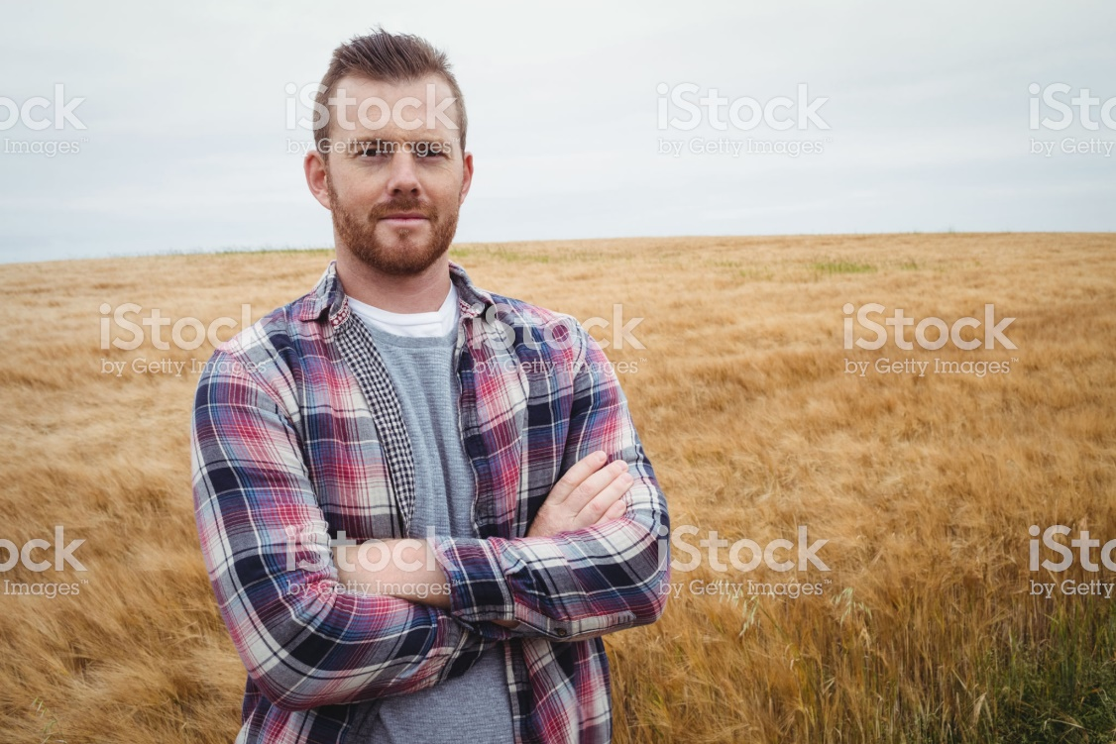

Thomas is a farmer by passion and the preservation of the farm in the fifth generation is his number one priority. He is proud when he goes out into the fields or when he enters the barn every day to take care of his cows. The milking robot performs the milking – investing in automation was a big concern for Thomas. Not only has he upgraded the barn, but also his office: Since taking over the farm, he has been using the NEXT Farming software and since December 2019 also the new NEXT Machine Management module.
Thomas has an affinity for technology, but is no “digital native". Nevertheless, he knows that he needs a future-proof solution to manage his farm. Because, like many other farmers, Thomas is facing the challenge presented by the fact that legal regulations such as the fertiliser ordinance and recording obligations have become stricter.

- Future-oriented design and highest data security
- Central component of the modular farm management system
- NEXT Farming^{LIVE} adapted to operational requirements
- NEXT Crop Planning and Documentation^{LIVE} as a powerful field database for fast, reliable and easy planning and documentation

Indoor farming with 100 dairy cows is extremely time-consuming and as the farm's manpower is limited, good time management in arable farming is extremely important. Professional documentation is therefore a crucial component in preparing for all inspections carried out by the authorities. Before implementing NEXT Machine Management, the actions and processes in the field had to be transferred manually to the management software at the end of each day using a USB stick. Thomas would have much rather spent this time with his family.
What he needed was a software tool that would make his office work noticeably easier and quicker. The documentation of his actions should take place automatically in the software, thus saving him an enormous amount of time in the office. The wireless transmission of order data to his machines would help speed up the process, as he often forgot his USB stick on his desk and had to return to the office to pick it up.

- Enormous time-benefits thanks to automatic documentation of the actions
- Wireless transfer of order data to your machines

NEXT Machine Management immediately convinced him, because it can process the machine data manufacturer-independently – providing one single system for all his agricultural machinery. For Thomas, this was the perfect solution to his time problem.
In the evening he still has to plan his tasks for the following days, but this is very easy and fast with the module. Thanks to the automatic documentation, he no longer needs to do any rework. He can simply think about tomorrow!

- Simple task planning.
- Automatic documentation.

Content, Thomas gets on his tractor early in the morning, he and his machine know exactly what to do today. Thomas feels safe, he trusts the NEXT Machine Management module – it records "live" for him the entire time and all process data is recorded.

- Fast data transfer.

